Jannah Mokhtar

October 28, 2023

Performing Robots

Professor Michael Shiloh

Paper 1 - Art, Science, and Robots: the multifaceted world of Ken Rinaldo

“This was my first trans-species experience. Here was a cat, finding pleasure in the taste of my earwax while we provided mutual affection.” This is what artist Ken Rinaldo describes as the experience that long left him questioning “animal-human communication, symbiosis and the contemporary notion of the computer interface” (Rinaldo, 2016). Ken Rinaldo is an innovator, an artist, and a scientist who comes from a computer science and art background, he was strongly influenced by scientists like James G. Miller, famous for creating “Living Systems Theory”, and artists like Marcel Duchamp, also known as the Father of Conceptual art (Rinaldo, 2023). Not only that, Rinaldo views himself as both a scientist and an artist, and his work resides at the crossroads of the two. This is apparent in a great deal of his work of robotic and bio-art installations. In order to achieve his objective of transforming abstract and difficult-to-understand phenomena into visual and interactive representations, the artist utilizes digital fabrication and visualization technologies, algorithms, and artificial intelligence. Besides that, he is passionate about biology because he wants to understand, investigate, and interact with living species that populate our planet, as well as recognize the peculiarities of the natural world. In the intersection of both fields, Ken Rinaldo focuses on “theories of life, symbiogenesis, trans-species communication, and providing models for how technological systems can use structural and process lessons from nature to be more sensitive to all living species.[…]The critical use of technology influences, changes, and further mutates my ideas, while the algorithms increasingly become a selective pressure in a co-evolution with intelligent machines.” (Rinaldo, 2023) Rinaldo’s work is unique and innovative in the sense that it interlaces a multitude of mediums and concepts to represent his final vision. An overlook of all his work begs the question: how does his work bridge between two seemingly disconnected worlds: robot art and science? In order to fully comprehend Ken Rinaldo's multifaceted role as a scientist and artist, as well as his overarching mission of bridging the two fields through robotic manifestations, it may be most effective to analyze a selection of his works within this broader thematic context.

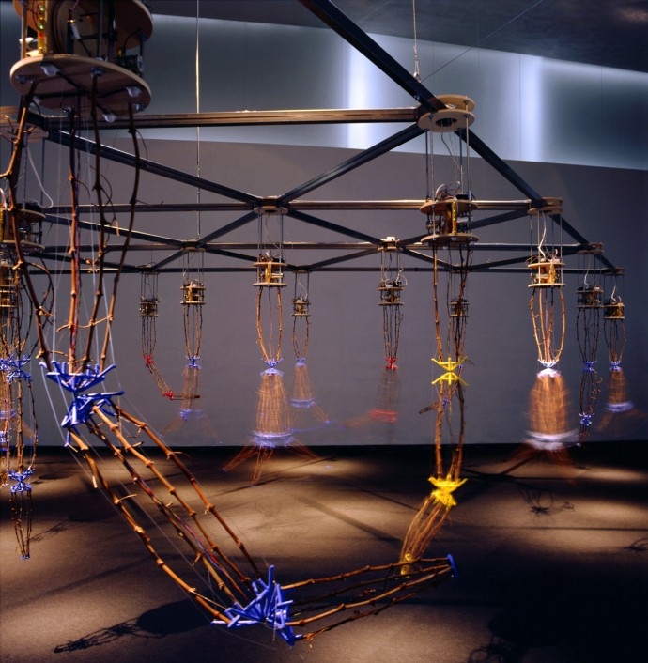Rinaldo expressed the idea of “inevitability to the arising of artificial machine intelligences” (Rinaldo, 2016), and the development of their “self-sustaining relationships with humans”. Furthermore, author Kevin Kelly develops this idea by stating how large systems of technology frequently behave like “a very primitive organism”. Specifically, electronic networks that display near-biological behavior (Kelly, 2010). This is where Rinaldo sets out to find an “interface” to this technology. Coined by biologists Humberto Maturana and his student Francisco Varela, *autopoiesis* describes the capacity of an entity to reproduce itself, later developing into *general systems theory* (Maturana and Varela, 1980). Ken Rinaldo was inspired by this concept and created the series *Autopoiesis*, which is a series of fifteen musical and robotic artificial life sculptures that “interact with the public and modify their behaviors based on both the presence of the participants in the exhibition and the communication between each separate sculpture”. The robotic sculptures, resembling robotic arms talk with each other through a network and audible telephone tones, which Rinaldo refers to as the “musical language for the group”. " Autopoiesis breaks out of standard interfaces (mouse) and playback methodologies (CRT) and presents an interactive environment, which is immersive, detailed, and able to evolve in real-time by utilizing feedback and interaction from the audience/participant members” (Rinaldo, 1998). By using robots and electronic components to mimic, interact with, and respond to biological organisms, Rinaldo’s artworks transgress the traditional boundaries that separate the natural and artificial worlds. This unique approach creates a coexistence of organic and mechanical elements that encourages a reconsideration of traditional distinctions between life and machines. Additionally, interactive works like *Autopoiesis* use sensors and feedback mechanisms to allow robots to respond to the presence and movements of audience members, creating interactive viewer involvement. *Autopoiesis* also delves into the concept of emergent characteristics within intricate structures, with robotic elements generating dynamic and unpredictable behaviors similar to natural systems. Rinaldo's artwork provokes philosophical and ethical discussion, encouraging reflection on the complex interactions that exist between technology, the environment, and people as well as the roles that each of us plays in influencing and shaping their future relationships.

1: Fifteen Arms of Autopoiesis artificial life robotic sculpture series commissioned by the Kiasma Museum of Contemporary Art, Helsinki, Finland. Feb. 2000. Invited. Photo Ken Rinaldo

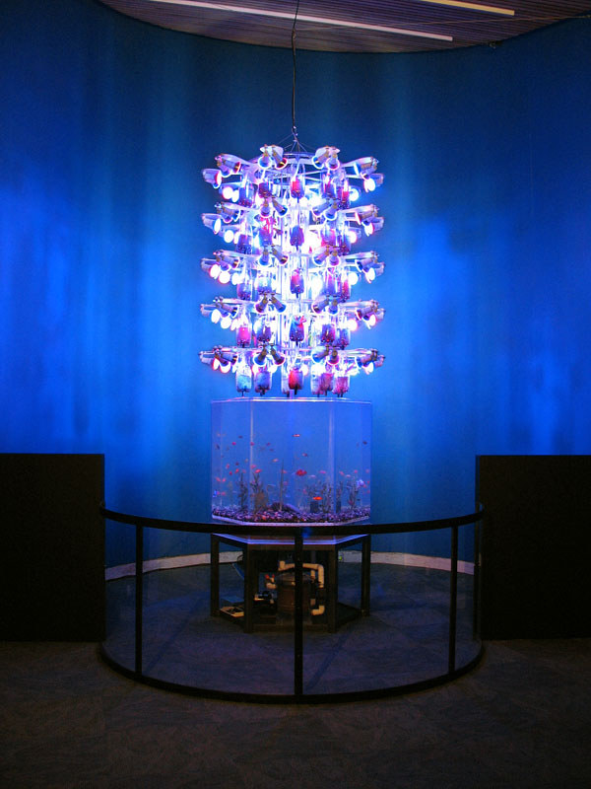Another example of Rinaldo’s work illustrating his will and goal to create and engage with living organisms through his eye-catching creations is *Farm Fountain*. This hanging garden fountain is a system used for growing “edible and ornamental fish and plants in a constructed, indoor ecosystem” The fountain uses aquaponics and gravity flow to recycle nutrients from fish waste for bacteria and plant roots, which in turn, cleanse and purify the water for the fish. This work aims to create a healthy indoor environment providing oxygen and light to humans and food. Rinaldo's "Farm Fountain" is another innovative illustration of his ability to fuse science and art via robotics and interactive installations. By exploring the intersection of technology, sustainability, and agriculture, this artwork helps to ensure that these fields are seamlessly integrated in the following ways: Robots play a vital role in monitoring and controlling the distribution of nutrients and water in the Fountain, forming a visually appealing and intellectually stimulating fusion of technology and agriculture. *Farm Fountain* also emphasizes how important environmentally responsible and sustainable farming methods are with alternate farming methods (like robots). Through the audience's interactions with the robots and their contributions to system maintenance, spectators actively participate in the maintenance of the hydroponic plants. This interactive element instills a sense of connection to the art and the scientific principles it embodies. Additionally, the Fountain serves as an educational experience that sparks interest in the ways that technology might solve problems related to food production and sustainability by illustrating the concepts of automation and hydroponic farming. It weaves together aspects of biology, technology, and agriculture to create a bridge between creative expression and scientific concepts. We can say that *Farm Fountain* is a prime example of Ken Rinaldo's ability to bring art and science together by creatively fusing technology, agriculture, and interaction into an immersive and thought-provoking visual experience.

2: Farm Fountain 4 by Ken Rinaldo and Amy Youngs at the Te Papa Museum, Wellington New Zealand. Curated by Randi Rosenberg. Photo Amy Youngs

In the ever-evolving realm of art and science, Ken Rinaldo's groundbreaking work in robotics has revealed an avenue where both fields converge, challenging traditional boundaries and prompting profound questions about the interplay between technology and the natural world. Other artists are delving into the field of robotics and science like David Bowen’s *Plant Machete*, an installation of a live plant protected by an automated machete, or Sun Yuan and Peng Yu’s *Can’t Help Myself,* an industrial robot that aims to examine our increasingly automated global reality (Atay et. al, 2020). As Rinaldo is pushing the boundaries of what is possible in this intersection, technology, biotechnology, and artificial intelligence advances seem to have no limits when it comes to the possibilities for combining science and art. Utilizing these tools, artists are looking into ecological systems, emerging behaviors, and the intricate interplay between them. As the field develops, we can anticipate an even larger integration of science and art. Ken Rinaldo and other visionary artists have created a bridge between art and science, a dynamic and constantly changing domain that is full of possibilities for exploration and innovation.

**Bibliography**

Atay, S, et al. “Present and Future Paradigms of Cyberculture in the 21st Century”. United States: IGI Global. 2020.

Bowen, D. <https://www.dwbowen.com/plant-machete>

Kelly, K. “What Technology Wants”. New York: Penguin Group. 2010.

Maturana, H. R., & Varela, F. J. “Autopoiesis and Cognition: The Realization of the Living”. D. Reidel Publishing Company. 1980.

Rinaldo, K. "Special Section: Artificial Life Art." Leonardo 31, no. 5. 1998.

Rinaldo, K. “Trans-Species Interfaces: A Manifesto for Symbiogenisis”. In: Herath, D., Kroos, C., Stelarc (eds) Robots and Art. Cognitive Science and Technology. Springer, Singapore. 2016.

Rinaldo, K. [www.kenrinaldo.com](http://www.kenrinaldo.com)

Rinaldo,K & Youngs, A. [www.farmfountain.com](http://www.farmfountain.com)

The Ohio State University. <https://art.osu.edu/people/rinaldo.2>